3rd Semester

Systems Development Methodologies

Project Charter

1 Introduction
During the second semester, you learned the iterative , incremental Unified Process approach . During this semester, you are learning a new approach: Agile development approach with focus on delivering high quality software.
You are going to do a project using agile systems development principles and practices, using mainly SCRUM combined with Extreme Programming XP.
The Project Report will be the basis for your exam in Systems Development, whereas the application (programming and technology) is not in focus at Systems Development exam.

2 Project objectives
The main goal of the project is to provide you, as a competent partner in a development project, an opportunity to use and evaluate new practices and methodologies and to give you some experience in being a customer. The project will result in a study report and a working (coded, tested) software.
The project will also give you an opportunity to use and evaluate many of the topics that are new to you in this semester and the previous semesters as well.
The primary objective is to get knowledge of and experience with agile practices. It is also an opportunity for improving your programming skills.

3 Requirements for distributed programming
The project idea is to implement the distributed architecture shown in the figure below.
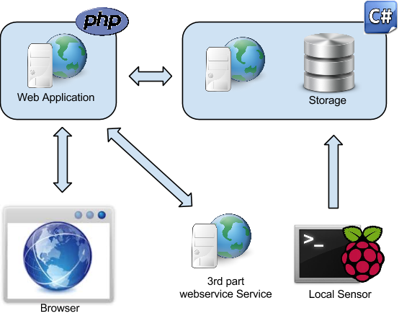

The application must:
- Access data from Azure using web services
- Have a middle-tier written in PHP
- Have a browser based user interface / website
- Be tested
- Be documented

4 The study project
The study project is based upon the course Systems Development Methodologies (SYM). The purpose of the study project is to give you an opportunity to use and evaluate a specific methodology by developing a system based on the architecture shown above .

5 Project scope and requirements
The methodology must be based on the new agile practices from e.g. XP, SCRUM. Mandatory practices and roles are:
- XP-Planning Game (all sprints)
- Informative workspace
- Collective ownership
- Test Driven Development
- Scrum practices
- Product owner Role

Each sprint must focus on and document a specific agile practice.
You must accomplish and present the study project methodically by carrying out the following stages:
- Problem definition (Formulate a Research Question)
- Problem solving (Project Work)
- Conclusion

6. Process Requirements

6.1 Team size
The team must consist of a cross-functional team of 1 members.

6.2 Project planning
The table below shows the schedule for each sprint
– see https://trello.com/b/IyUhkN70/christoffer

6.3 Report size and form
The size of your study project report must be at minimum 20 pages and at maximum 30 pages (a page is 2400 characters including spaces).
Attest the number of characters in your report.
Your report must also document the role of a team as a Product Owner (PO).
The report must follow normal practice with frontpage, table of content, page numbers. etc.

6.4 Supervisors
Your teachers in this semester are the supervisors/facilitators for the project. During the project period, they will be at your disposal providing advice and help.

6.5 What to deliver and when
E-mail to pele@easj.dk:
- Project report
- Coded and tested software (C# code, executable program, installation instructions, etc.) as a zipped file
- Hand-in on 13/01/2017 no later than 16:00

